Pin modification:

P0.8 -> P0.6

P0.9 -> P0.7

Output (UART #2 ) explanation

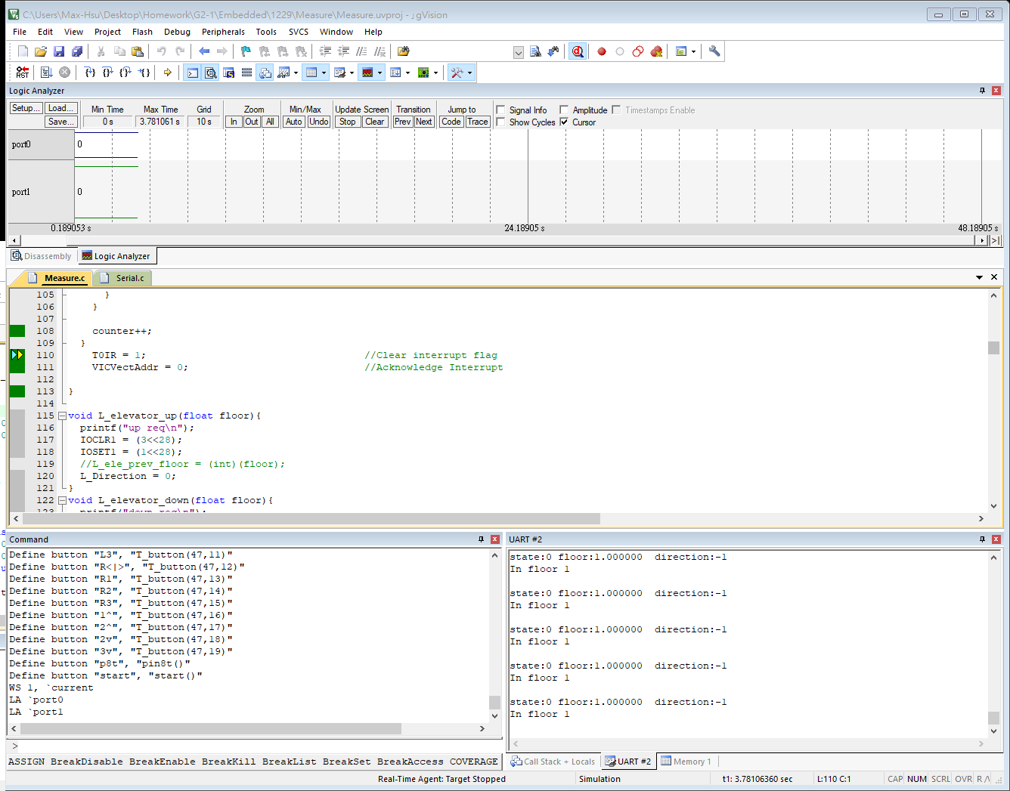

State : the elevator’s current state

0 for fully closed

1 for opening

2 for fully opened

3 for closing

If the state of the door is changing

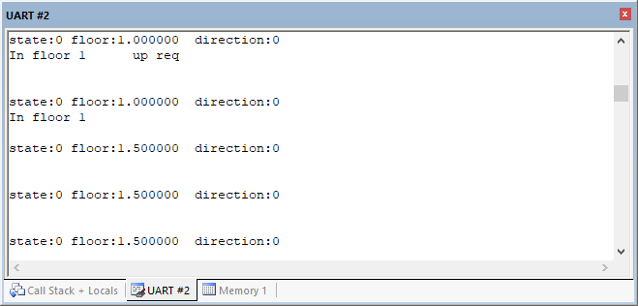

The current situation will also show

Floor : the current floor the elevator is

Direction : the direction of the elevator is going

0 for up

1 for down

Unfix bugs

1. sometimes IOSET1 didn’t set the value

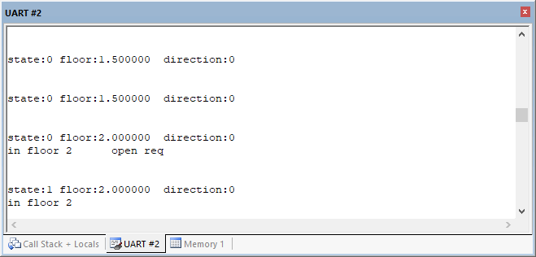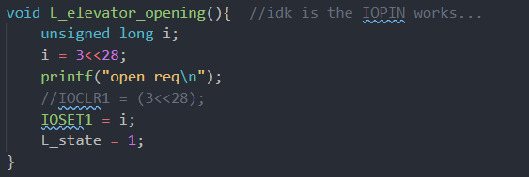

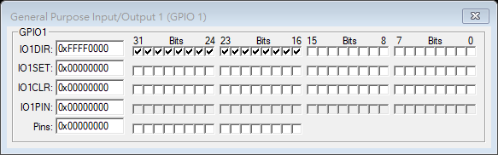

Nothing happen

1. Even sometimes IOSET had successes set the port1 , sometimes measure fail to read the value and…

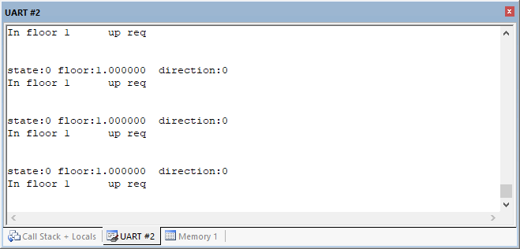

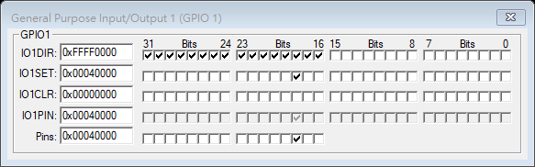

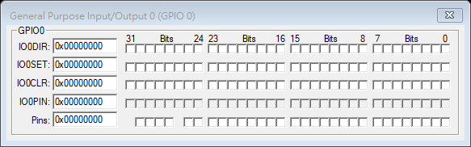

GPIO0 for midfloor never changes

